**Chapter 10 – Programming Assignment Hung Le**

**Question 2:**

const list =[17, 8, 9, 5, 20];

function addEnds(list) {

return list[0] + list[list.length-1];

}

let value = addEnds(list);

console.log(value);

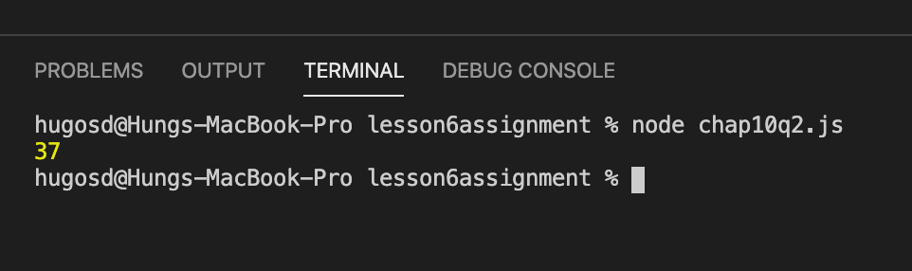

**Question 3:**

let list = [17, 8, 9, 5, 20];

function getMiddle(list) {

if (list.length === 1) {

let oneValue = `This arry has only one value. It is ${list[i]}`;

return oneValue;

} else if(list.length % 2 !==0) {

let midValue = list[Math.floor(list.length/2)];

return midValue;

} else if (list.length % 2 ===0) {

let left = list[((list.length-2)/2)];

let right = list[list.length/2];

let averageValue = (left + right)/2;

return averageValue;

}

}

let value = getMiddle(list);

console.log(value);

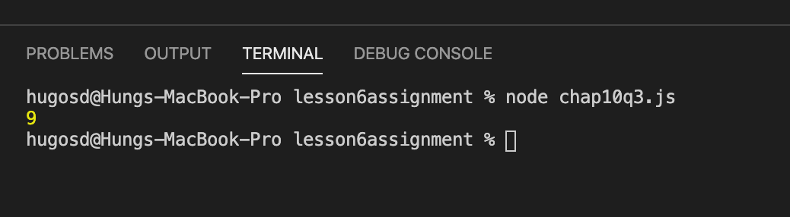

let list = [12, 4, 8, 15, 17, 5, 20, 11];

function getMiddle(list) {

if (list.length === 1) {

let oneValue = `This arry has only one value. It is ${list[i]}`;

return oneValue;

} else if(list.length % 2 !==0) {

let midValue = list[Math.floor(list.length/2)];

return midValue;

} else if (list.length % 2 ===0) {

let left = list[((list.length-2)/2)];

let right = list[list.length/2];

let averageValue = (left + right)/2;

return averageValue;

}

}

let value = getMiddle(list);

console.log(value);

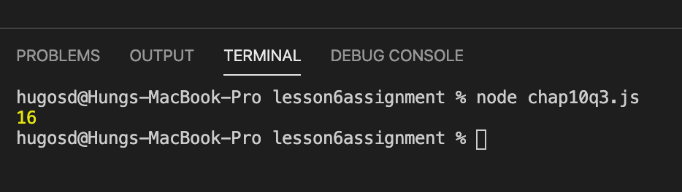

**Question 4:**

let list = [17, 8, 9, 5, 20];

function countEvens(list) {

let j = 0

for (i = 0; i < list.length; i++) {

if (list[i] % 2 === 0) {

j++;

}

}

return j;

}

let count = countEvens(list);

console.log(count);

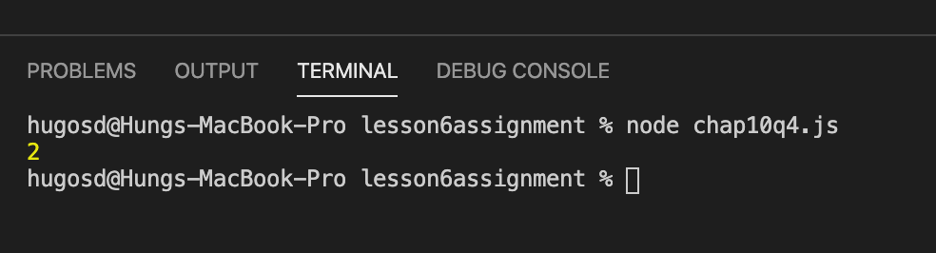

**Question 5:**

function multiply(list, multiplier) {

let new_list = [];

for (let i = 0; i < list.length; i++) {

new_list[i] = list[i] * multiplier;

}

return new_list;

}

let list = [17, 8, 9, 5, 20];

let products = multiply(list, 3);

console.log(products);

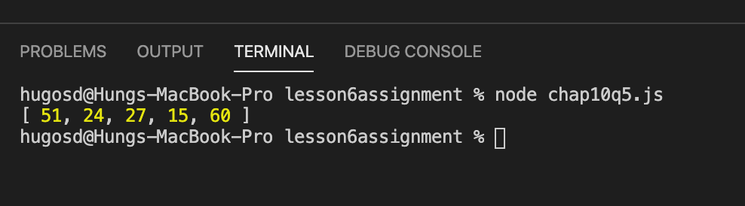

**Question 6:**

function rotateLeft(list) {

let tempt_value = list[0];

for (let i = 0; i < list.length; i++) {

list[i] = list[i + 1];

}

list[list.length - 1] = tempt_value;

return list;

}

let list = [17, 8, 9, 5, 20];

list = rotateLeft(list);

console.log(list);

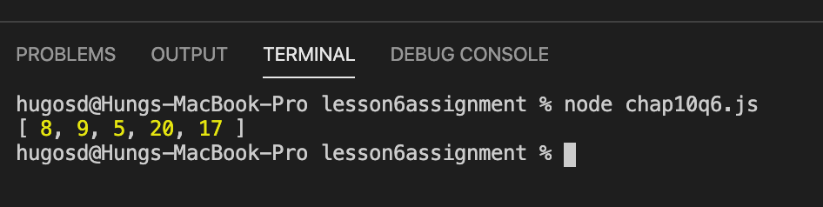

**Question 7:**

function rotateRight(list) {

let tempt_value = list[list.length-1];

for(let i = list.length-1; i >=0; i--) {

list[i] = list[i-1];

}

list[0] = tempt_value;

return list;

}

let list = [17, 8, 9, 5, 20];

list = rotateRight(list);

console.log(list);

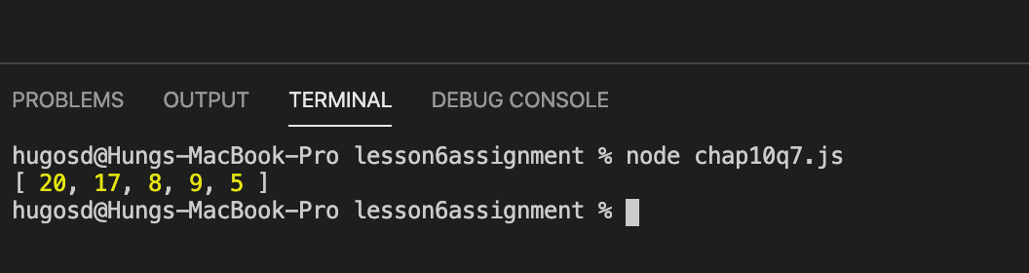

**Question 10:**

let prompt = require("prompt-sync")();

let n = prompt("Please enter a number from 1 to 12: ");

let day = ["first", "second", "third", "fourth", "fifth", "sixth", "seventh", "eighth", "ninth", "tenth", "eleventh", "twelfth"];

let gift = ["a partridge in a pear tree", "two turtle doves", "three French hens", "four calling birds", "five golden rings", "six geese a laying", "seven swans a swimming", "eight maids a milking", "nine ladies dancing", "ten lords a leaping", "eleven pipers piping", "twelve drummers drumming"];

let dayCounter = day[n - 1];

let giftCounter = gift[0];

if(n >1) {

for (let i = 1; i < n; i++) {

giftCounter = "and " + gift[0] + ".";

for (let j = 1; j <= i; j++) {

giftCounter = gift[j] + ", " + giftCounter;

}

}

}

let lyrics = "On the " + dayCounter + " day of Christmas, my true love gave to me: " + giftCounter;

console.log(lyrics);

